Community Foundation News


No. 57 December 20, 2006

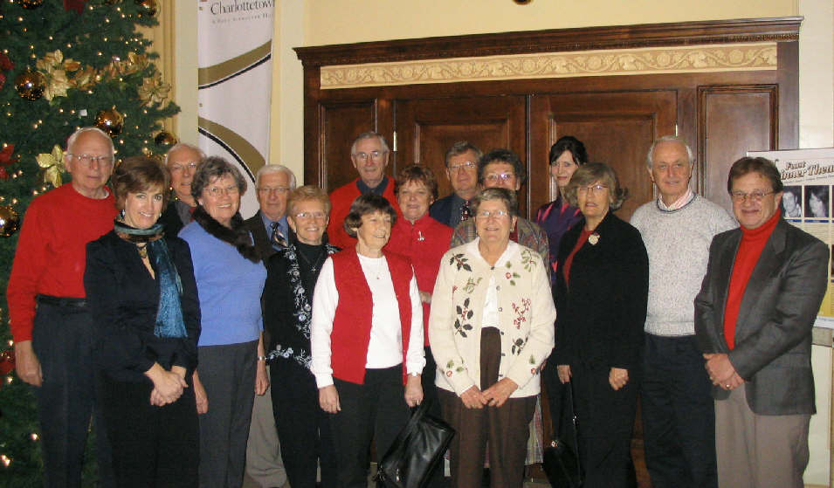
The Foundation Family at our annual Christmas luncheon at the Charlottetown Hotel

Correction

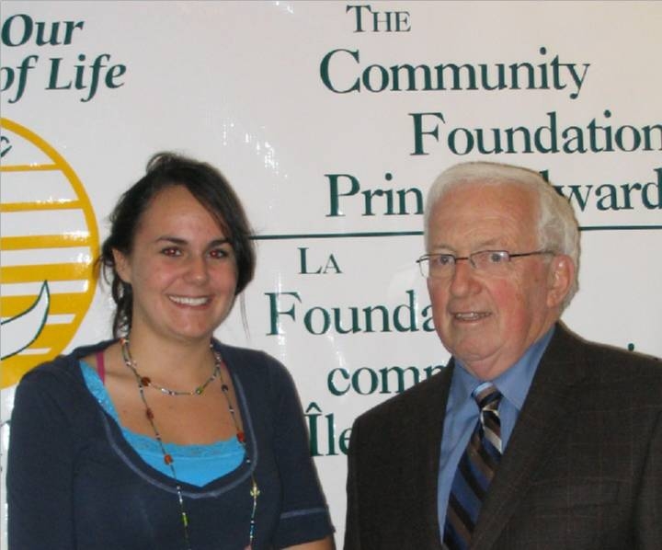
This photo appearing in the last issue should have read: Norman Carruthers with Jocelyn LaPorte of Students Against violence Everywhere. My apologies

_______________________________________
The Community Foundation News is an informal newsletter, in electronic form only, edited and published by, and at the whim of, Don Glendenning. Think of it as a letter from a friend. Forward this to others who may be interested. For further information, check our website, www.cfpei.ca or Email me at: dglende@auracom.com
‘Tis the Season

On behalf of the Community Foundation of Prince Edward Island, we offer:
- Congratulations to the Found-ation family on a successful year,
- Thanks to all Islanders for their gifts of time and talent for the betterment of our Island community,
- Best wishes for good health and peace in the coming year,
- An opportunity to enhance our Island community. To paraphrase Mahatma Gandhi:

We must be the change
we wish to see in the world

